

REGULATIONS MADE IN TERMS OF

Aged Persons Act 81 of 1967

section 20

**Regulations framed under the Aged Persons Act, 1967, in respect of Bantu in the Republic and Natives in South-West Africa, including the Eastern Caprivi Zipfel**

RSA Government Notice R.1813 of 1968

([RSA GG 2182](http://www.lac.org.na/laws/GGsa/rsagg2182.pdf); re-published in [OG 2944](http://www.lac.org.na/laws/1968/og2944.pdf))

came into force on date of publication: 29 November 1968

RSA GN R.1813/1968 states:

“The Minister of Bantu Administration and Development has in terms of section 20(1) of the Aged Persons Act, 1967 (Act No. 81 of 1967), read with Proclamation No. R.283 of 1968; and with Proclamation No. R.293 of 1968, made the regulations contained in the Schedule in respect of Bantu in the Republic and Natives in the Territory of South-West Africa,including the Eastern Caprivi Zipfel, and approved the repeal of Government Notice No. R.2080 of 1966.”

as amended by

Native Laws Amendment Proclamation, AG 3 of 1979([**OG 3898**](http://www.lac.org.na/laws/1979/og3898.pdf))

deemed to have come into force in relevant part on 1 August 1978 (section 5 of AG 3 of 1979)

RSA Government Notice R.1034 of 1974 ([RSA GG 4308](http://www.lac.org.na/laws/GGsa/rsagg4308.pdf))

came into force on 1 May 1974 and made explicitly applicable to SWA (RSA GN R.1034/1974);

withdraws RSA GN R.1813/1968 “as far as it relates to pension matters”

There were numerous amendments to RSA GN R.1813/1968 that concerned only the provisions   
of the regulations relating to pensions, which were withdrawn by RSA GN R.1034/1974.

The original Act dealt with old age pensions, but this portion of the Act was repealed by section 21 of the *Social Pensions Act 37 of 1973* ([RSA GG 3866](http://www.lac.org.na/laws/GGsa/rsagg3866.pdf)), which was applicable to SWA but has since been repealed by the National Pensions Act 10 of 1992. The numerous amendments pertaining   
to pensions are accordingly not listed here.

ARRANGEMENT OF REGULATIONS

1. Definitions

2. Application for registration of a settlement for aged Blacks

3. Minimum standards to be met by settlements for aged Blacks for purposes of registration

4. Registration of settlement for aged Blacks

5. Registers of residents to be kept

6. Books of account

7. Financial assistance to welfare organizations

[Regulations 8-17 concern old age pensions and are thus withdrawn by RSA GN R.1034/1974.]

18. Appeals

Annexure 1 - Application for Registration of Settlement for Aged Blacks

Annexure 2 - Certificate of Registration of a Settlement for Aged Blacks

Annexure 3 - Certificate of Provisional Registration of Settlement for Aged Blacks

[Annexures 4-6 concern old age pensions and are thus withdrawn by RSA GN R.1034/1974.]

[The terminology throughout the regulations is amended by AG 3/1979. Where “Bantu” is   
used only in relation to South Africa, as in the title of the regulations and in portions of the definition of “Bantu” in regulation 1, the term has not been altered.]

**Definitions**

**1.** In these regulations, unless the context otherwise indicates -

[The definition of “applicant” relates to pensions and is thus withdrawn by RSA GN R.1034/1974.]

“Black” means any person classified as a Bantu under the Population Registration Act, 1950 (Act No. 30 of 1950), and includes, in the Territory of South-West Africa, including the Eastern Caprivi Zipfel, a Native, as defined in section 25 of the Native Administration Proclamation, 1928 (Proclamation No. 15 of 1928), of South-West Africa;

“Commissioner” means the Commissioner appointed with jurisdiction in terms of section 2 of the Black Administration Act, 1927 (Act No. 38 of 1927);

“the Act” means the Aged Persons Act, 1967 (Act No. 81 of 1967);

“authorized officer” means any officer in the Public Service, to whom the Secretary has delegated the performance of certain functions under section 18(2) of the Act;

“Chief Commissioner” means the Chief Commissioner appointed with jurisdiction in terms of section 2 of the Black Administration Act, 1927 (Act No. 38 of 1927);

“Minister” means the Minister of Plural Relations and Development;

“settlement” or “settlement for aged Blacks” includes a home for the aged;

[The definitions of “pension” and “pensioner” relate to pensions   
and are thus withdrawn by RSA GN R.1034/1974.]

“Secretary” means the Secretary for Plural Relations and Development;

[The definition of “two-month period” relates only to pensions   
and is thus withdrawn by RSA GN R.1034/1974.]

“Republic” means the Republic of South Africa, including the Territory of South-West Africa including the Eastern Caprivi Zipfel;

“South African citizen” includes a Native who is a *bone fide* resident of the Territory of South-West Africa, including the Eastern Caprivi Zipfel.

[The term “*bona fide*” is misspelt in the *Government* *Gazette*, as reproduced above.]

**Application for registration of a settlement for aged Blacks**

**2.** (1) An application by the management of a settlement for aged Blacks for registration of such settlement under section 3 of the Act or for the amendment of a registration certificate shall be submitted to the Commissioner in duplicate on a form substantially in the form prescribed in Annexure 1.

(2) Any such application shall he submitted by the Commissioner through the Chief Commissioner to the Secretary for consideration, together with such Commissioner’s findings as to whether the buildings, general health facilities and service systems conform to the minimum standards, in accordance with regulation 3, for the accommodation of the proposed number of aged persons.

(3) Upon receipt of the application, the Chief Commissioner shall make such further investigations as he may deem necessary and forward the application, together with his comments and recommendation, to the Secretary.

**Minimum standards to be met by settlements for aged Blacks for purposes of registration**

**3.** (1) The management of a settlement for aged Blacks shall assume responsibility for the full social care of its residents and shall make provision for -

(a) freedom of movement of residents and the necessary social intercourse and facilities to encourage visiting by and to friends and relations;

(b) utilisation of leisure, freedom of worship and a pleasant homely atmosphere.

(2) The following requirements shall also be met -

(a) in respect of any bedroom -

(i) a floor area of not less than 30 square feet per occupant;

(ii) air space of not less than 300 cub. feet per occupant;

(iii) a window area (glazed area) equivalent to 1/10th of the floor area;

(iv) cross-ventilation through one or two windows or a door so placed as to give a draught or cross-ventilation;

(b) a minimum height of 8 feet shall be allowed between the floors and ceilings of living-rooms, bedrooms and recreation rooms;

(c) there shall be facilities for the hygienic preparation and serving of food, as well as general measures to ensure hygienic housekeeping;

(d) precautions shall be taken for the protection of the buildings in which residents are accommodated against fire, veld fires or flood damage;

(e) the buildings, bedding and furniture shall be in a good general condition;

(f) efforts shall be made to create a pleasant atmosphere in order to make residents feel at home and make their stay pleasant;

(g) bedrooms shall be provided with adequate storage facilities for clothing and other personal effects of each resident aged person;

(h) suitable ablution facilities and latrines shall be provided for residents;

(i) separate ablution facilities and latrines shall be provided for the different sexes and race groups;

(j) the nature and equipment of the ablution and toilet facilities shall be such as not to endanger the safety of residents;

(k) settlements for aged Blacks shall make provision for a dispensary and surgery for the use of a medical practitioner if there is no hospital within easy reach. All medicines, drugs and poisons shall be kept under lock and key and a record shall be kept of all medicines, drugs and poisons received and removed; with proper entries made of the purpose for which such medicines, drugs and poisons were removed and the name of the staff member to whom they were handed, whose signature therefore shall be obtained; and

(l) provision shall be made for occupational therapy for residents.

(3) (a) There shall be adequate staff for the proper care of residents;

(b) adequate arrangements shall be made for the treatment of residents by a qualified medical practitioner, where necessary.

(4) Full records shall be kept of the purchase and consumption of foodstuffs and such records shall at all times be open to inspection by a Commissioner or any other person designated by the Secretary.

**Registration of settlement for aged Blacks**

**4.** (1) After consideration of all the available particulars and if he is satisfied that the settlement is so managed and conducted as to be to the benefit of he aged residents and conforms to all the requirements of these regulations, the Minister may approve the application for registration and grant the settlement a certificate substantially in the form prescribed in Annexure 2.

[The word “the” is misspelt” ”in the *Government Gazette* in the phrase   
“to the benefit of the aged residents, as reproduced above.]

(2) If the settlement does not conform to all the prescribed requirements, the Minister may issue a temporary registration certificate substantially in the form prescribed in Annexure 3 specifying the requirements still to be met, as well as the period within which such requirements shall be met: Provided that, if the Minister is satisfied that it is not possible for any reason for the management of the settlement to comply with the requirements concered, he may exempt the management of such settlement from such requirements and issue a permanent registration certificate in respect of the settlement.

[The word “concerned” is misspelt” in the *Government Gazette* in the phrase   
“to comply with the requirements concerned”, as reproduced above.]

(3) The conditions and any provisions of a registration certificate issued under this regulation may be amended by the Minister from time to time after consultation with the management: Provided that nothing contained in this regulation shall be deemed to derogate from the powers to cancel any certificate vested in the Minister in terms of section 3 of the Act or the right of the holder of such certificate to surrender it.

**Registers of residents to be kept**

**5.** (1) The manager of every settlement shall see that a register is kept of the aged persons admitted thereto in which shall be recorded in respect of each aged person -

(a) date of admission;

(b) full names, ethnic relationship and sex;

(c) identity number and date of birth or estimated date of birth;

(d) particulars of income and source of income;

(e) names, addresses and telephone numbers of next of kin;

(f) date of departure from the settlement or date of decease and cause of death; and

(g) any periods of absence from the settlement, whether on leave or otherwise.

(2) The manager of a settlement shall keep a personal file for each resident in which the following shall be filed -

(a) medical history of the resident;

(b) all available particulars of his or her living children and other next of kin;

(c) particulars of funeral arrangements in the event of death and where his or her will, if any, is kept;

(d) an inventory of all personal effects kept in the settlement; and

(e) correspondence in connection with him or her.

(3) A full record shall be kept of receipts and expenditure of any moneys administered by the manager in respect of the aged person.

**Books of account**

**6.** (1) The manager of a settlement shall keep proper books of account accurately reflecting the following -

(a) all sums of money received and the value of receipts in kind and the date and source thereof;

(b) all disbursements, properly supported by vouchers, showing the date of payment, name of supplier and nature of the goods supplied or services rendered for which payment is made.

(2) The manager of a settlement shall annually, at the close of the financial year, submit to the Secretary audited financial statements including a balance sheet and a statement of revenue and expenditure.

(3) The manager of the settlement may be called upon by the Secretary to furnish returns for any calendar year or for any other period on forms supplied for the purpose of statistics of aged persons who are being cared for in the settlement, have been admitted or have left the settlement, as well as in respect of staff.

**Financial assistance to welfare organizations**

**7.** (1) Any grant made to any welfare organization referred to in section 2(b) of the Act shall be made subject to such conditions as the Secretary may specify in consultation with the Treasury.

(2) The welfare organization shall furnish the Secretary, when required by him to do so, with audited statements of account for any financial year, including a balance sheet and a statement of revenue and expenditure drawn up in such manner as the Secretary may determine.

(3) At the request of the Secretary a report on the activities of the welfare organization shall be submitted to him on such date as he may determine.

[Regulations 8-17 concern old age pensions and are thus withdrawn by RSA GN R.1034/1974.]

**Appeals**

**18.** (1) Any applicant and any pensioner who is dissatisfied with any action or decision of the authorized officer and who desires to appeal to the Minister shall lodge with the authorized officer within ninety days of the date on which such action or decision came to the notice of such applicant or pensioner a notice in writing setting out the action or decision appealed against and the reasons for dissatisfaction.

(2) Any authorized officer with whom any notice of appeal is lodged under subregulation (1) shall without delay and after furnishing his comments transmit such notice for consideration by the Minister whose decision he shall convey in writing to the appellant immediately he is informed thereof.

ANNEXURES

To view content without printing, scroll down.

To print at full scale (A4), double-click the icon below.



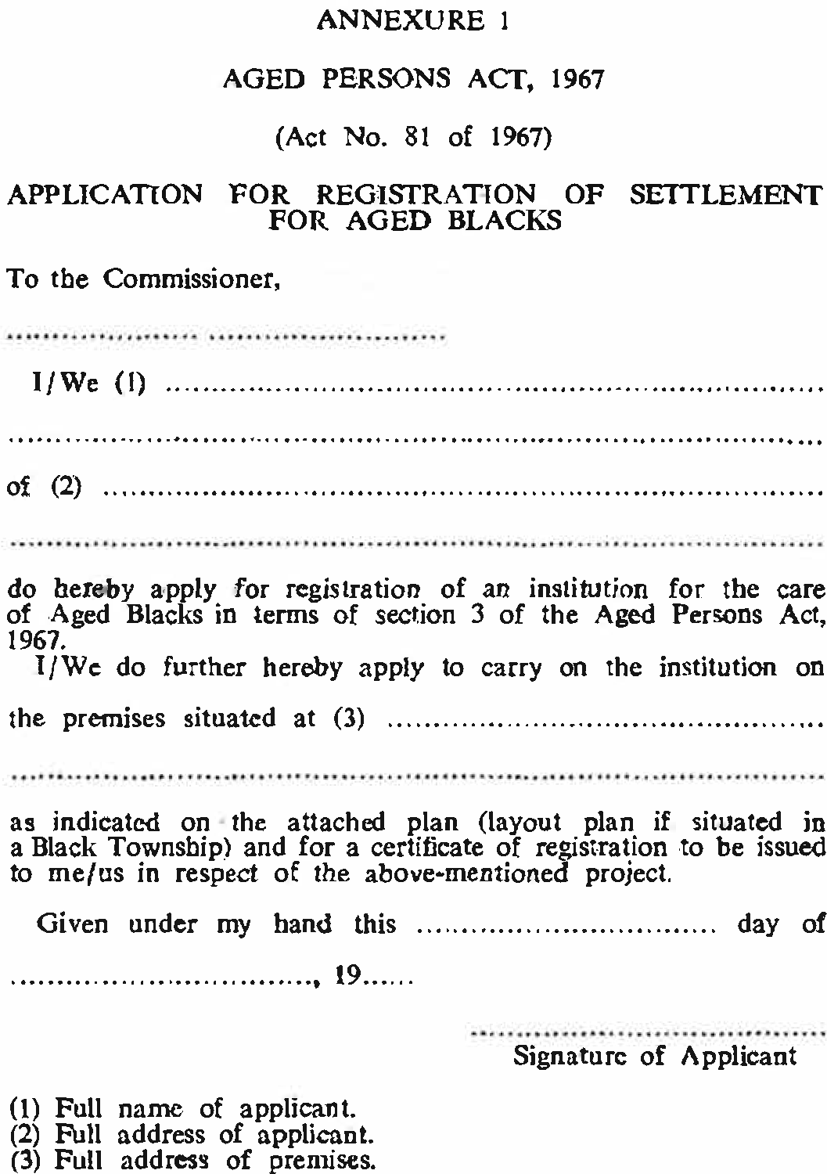

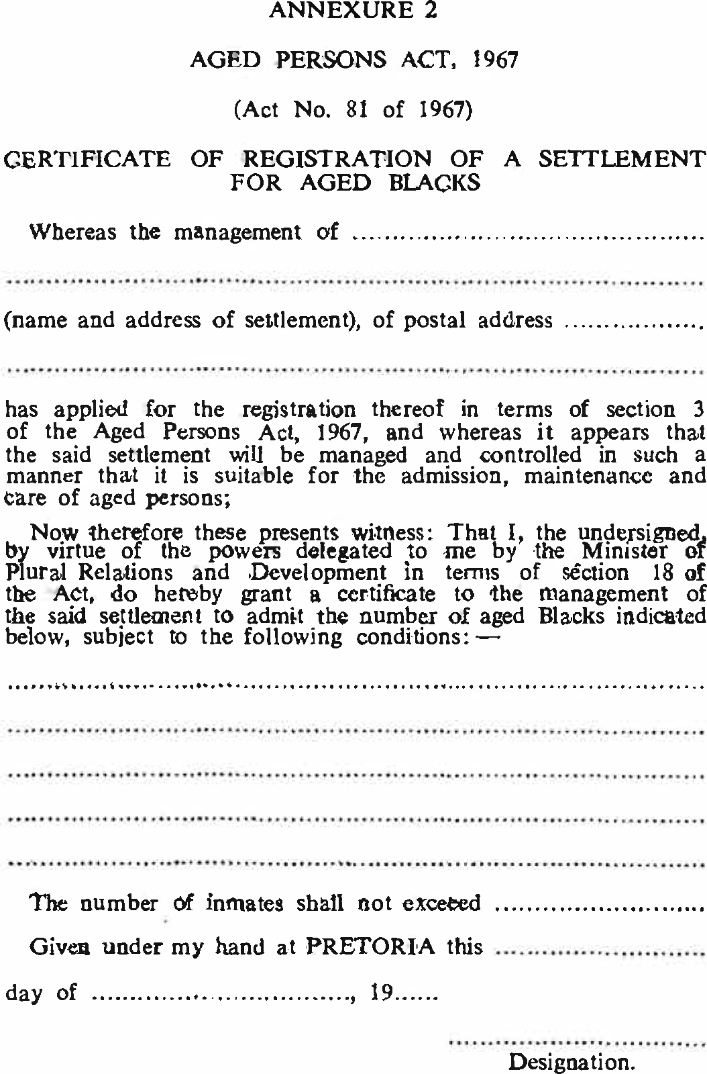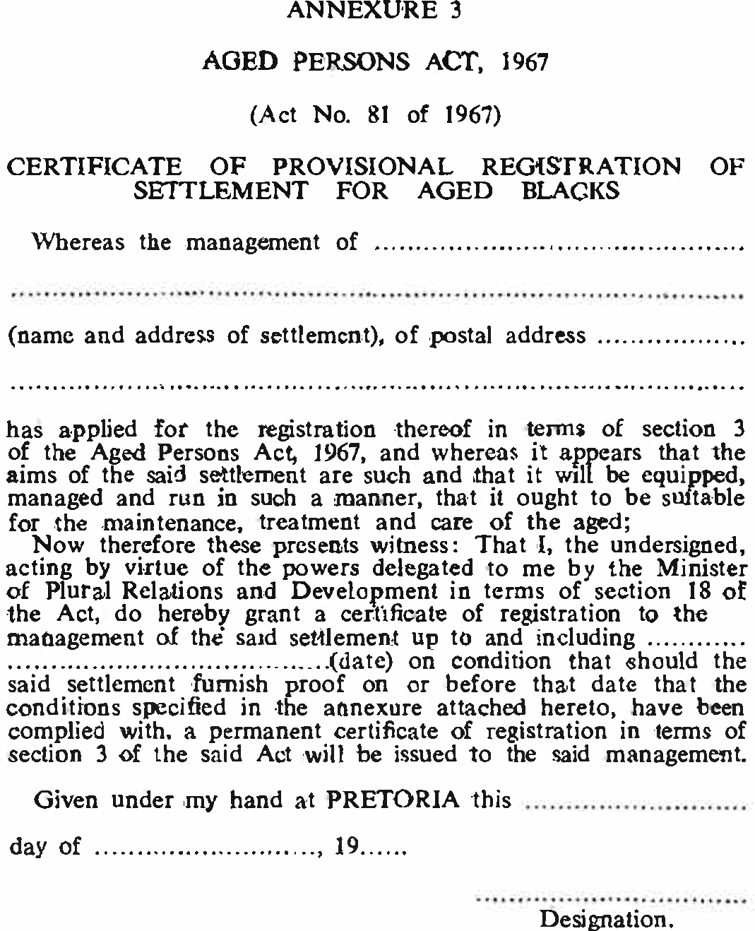

[Annexures 4-6 concern old age pensions and are thus withdrawn by RSA GN R.1034/1974.